Date of Inspection | <<Select Risk Cover Date>>

Policy Number: | <<Enter Policy Number>>

NOTES
- Please ensure that you complete all information required, any information not supplied or incorrectly given could result in any claims not being paid.
- Vehicle Inspection must be done within 24hrs of the policy inspection date after this period your cover will be limited to third party cover only until the inspection has been received by us.
- Please ensure you add all additional accessories and their value to the additional comments block.
- Please send the completed inspection certificate to clientservices@affinityum.co.za

Policy Information
Policy Holder | <<Enter Policy Holder Title, Initials and Surname>>
Policy Holder Id Number | <<Policy Holder Id>>
Registered Owner | <<Enter Registered Owner Title, Initials and Surname>>
Regular Driver | <<Add Regular Driver Initials, Surname, and Id Number>>
Cover Start Date | <<Select cover start date>>
Risk Address | <<Add Address Line 1>>  <<Add Address Line 2>>  <<Add Suburb>>  <<Code>>

Motor Vehicle Information
Vehicle Description | <<Year, Make and Model>>
Licence Number (From Disk) | <<Licence Disk Number>> | Licence Disk Expiry Date | <<Licence Disk Expiry Date>>
Vin Number | <<Vehicle Vin Number>> | Engine Number | <<Vehicle Engine Number>>
Vehicle Registration Number | <<Vehicle Registration Number | Odometer (Km’s) | <<Odometer reading>>
Vehicle Colour | <<Choose colour>> | Type of paint finish | <<Choose use type>>

Finance House Noting of Interest
Finance House | <<Select option>>

Vehicle Inspection Check List
Is the vehicle licence disk still valid? | Select | Does the drivers of the vehicle have valid SA drivers Licence? | Select
Do You have an alarm/ant theft system? | Select | Do you have a tracking device fitted> | Select
Is the vehicle sound system upgraded? | Select | Is there any damage to the vehicle? | Select
Is the vehicle interior in a good condition | Select | Is the vehicle exterior in a good condition? | Select

Additional Comments | <<Add any additional Comments and additional accessories here>>

Photo Guidelines Instructions:
- In order for your inspection to be valid we require several photos of the vehicle from a number of different angles.

- Please read the following instructions and requirements carefully
- To insert your image, click on the picture icon to download.

Front end
- Please ensure that the engine of the vehicle is visible including the number plate of the vehicle.
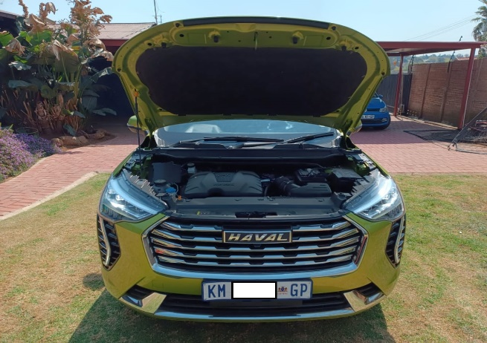

- Please ensure that the bonnet is closed and that the whole front of the vehicle including the licence plate is visible
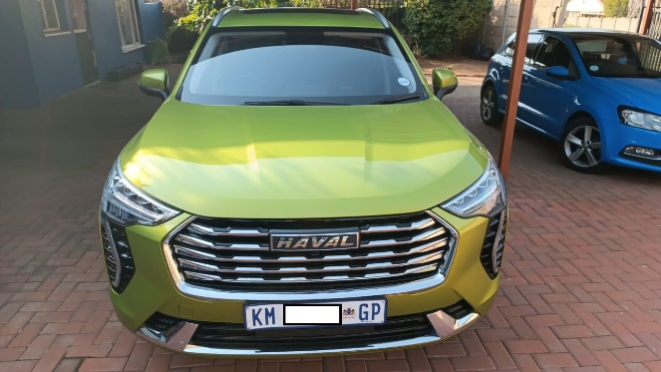

Rearend
- Please ensure that the number plate of the vehicle is visible. .
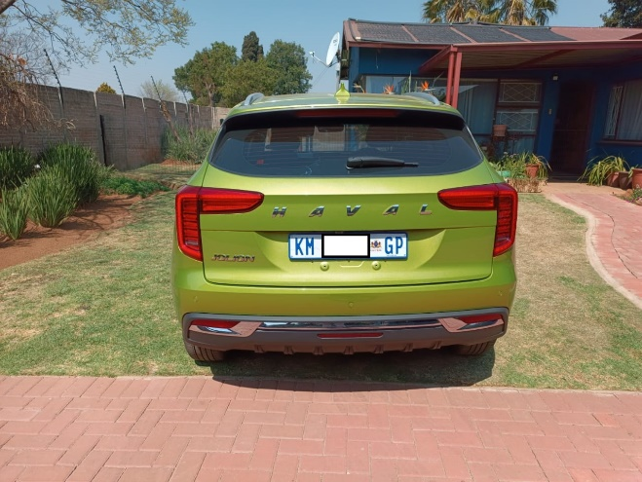

Sides of the vehicle
- Left side - Please ensure that the entire vehicle is visible including the wheels.
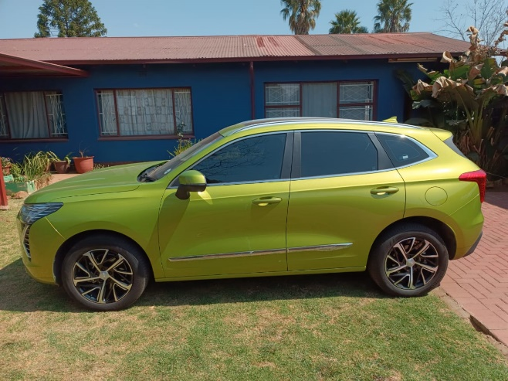

- Right side - Please ensure that the entire vehicle is visible including the wheels.
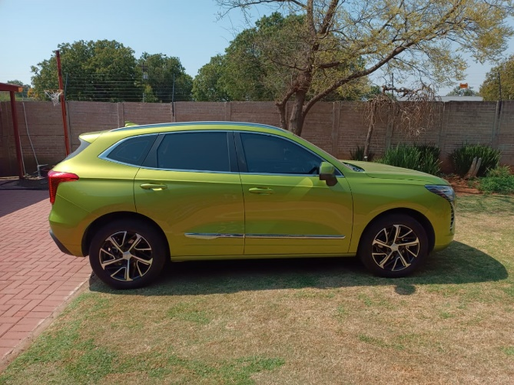

Instrument Cluster
- Please ensure that the gauges and numbers are clearly legible.
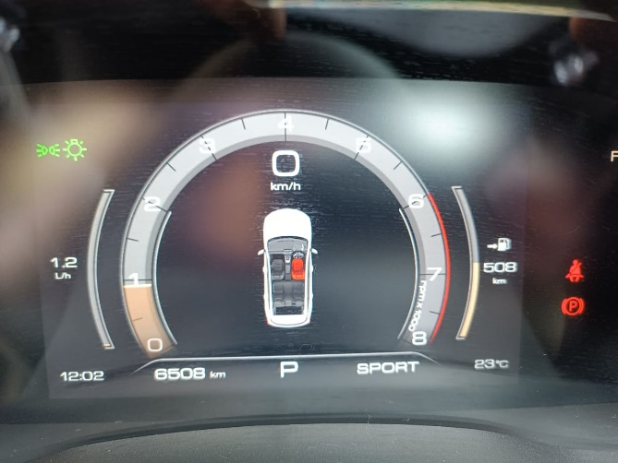

License Disc
- Please ensure that all writing on the disc is clearly legible.
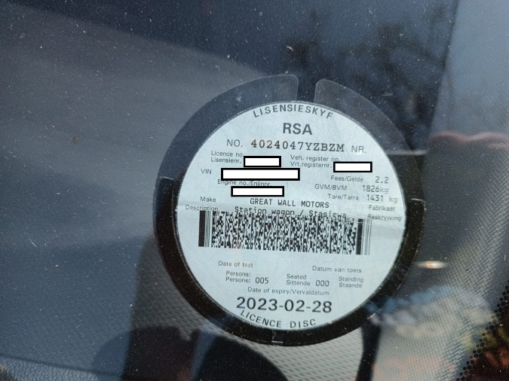

Copy of Drivers Licence
- Please ensure that all writing on the licence is clearly legible.

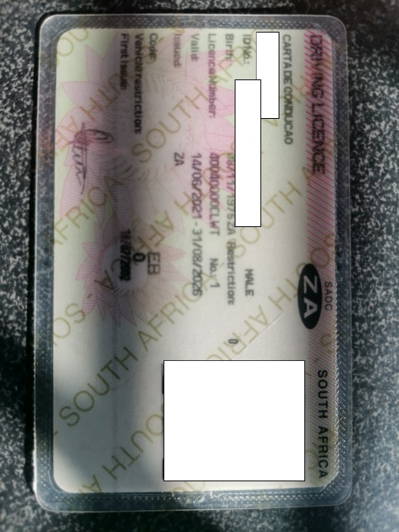

Declaration
- I understand and accept information supplied in this inspection report are true and accurate.
- I confirm that the content of the inspection report includes any and / or all vehicle accessories as at the time of the inspection being completed.

Accepted by | <<Enter Policy Holder Title, Initials and Surname>>
Date of completion | <<Select cover start date>>

_____________________________
Signature

